## Project Design Phase-II

**Technology Stack (Architecture & Stack)**

|  |  |
| --- | --- |
| 📅 Date | 31 January 2025 |
| 👥 Team ID | LTVIP2025TMID31117 |
| 👥 Team Size | 4 |
| 👑 Team Leader | Sai Vinay Biruda |
| 👤 Team Members | - Pilli J V Durga Prasanna Kumar  - Pradeep Kumar  - Pattucharla Lakshmi Anjana Sridevi |
| 📌 Project Name | Workforce Administration Solution (Dev) |

### Technical Architecture

The Workforce Administration Solution is designed using Salesforce architecture components to deliver a scalable, secure, and user-friendly platform for managing employees, projects, and assets. A high-level architecture diagram illustrates interaction between the user interface, Salesforce automation, data storage, and reporting components.

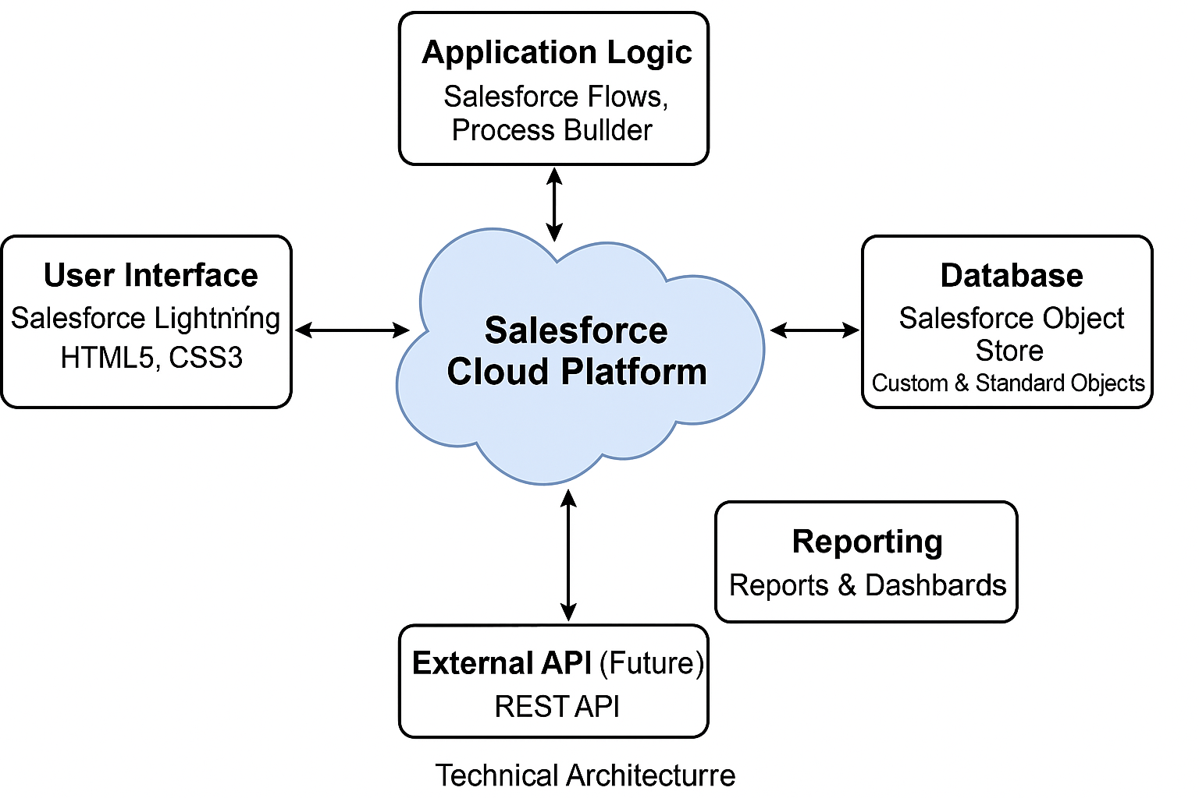

### Table 1: Components & Technologies

| S.No | Component | Description | Technology |
| --- | --- | --- | --- |
| 1 | User Interface | Web-based interface on Salesforce Lightning | Salesforce Lightning, HTML5, CSS3 |
| 2 | Application Logic | Automation and workflows | Salesforce Flows, Process Builder |
| 3 | Database | Data storage and relationships | Salesforce Object Store (Custom & Standard Objects) |
| 4 | Reporting | Dashboards and analytics | Salesforce Reports & Dashboards |
| 5 | External API (Future) | Integration with HR systems | REST API (planned for future scope) |
| 6 | Infrastructure | Cloud hosting | Salesforce Cloud Platform |

### Table 2: Application Characteristics

| S.No | Characteristics | Description | Technology |
| --- | --- | --- | --- |
| 1 | Open-Source Frameworks | NA (Salesforce proprietary platform) | NA |
| 2 | Security Implementations | Role-based access, field-level security, Salesforce Shield (optional) | Salesforce IAM, Shield |
| 3 | Scalable Architecture | Multi-tenant cloud platform supporting scalability | Salesforce Cloud Architecture |
| 4 | Availability | High availability ensured by Salesforce infrastructure | Salesforce Platform HA features |
| 5 | Performance | Optimized with standard best practices, caching within Salesforce reports | Salesforce Lightning, report optimizations |